



Python Program Demonstrating Multiple Inheritance
LAB MANUAL

Disclaimer: The content is curated from online/offline resources and used for educational purpose only
Python Program Demonstrating Multiple Inheritance

Objectives:
- To understand and implement multiple inheritance in Python using classes.
- To create two base classes, Person and Employee, which provide common functionality for name and employee ID management.
- To create a derived class Manager that inherits from both Person and Employee, combining their attributes and methods.
- To demonstrate how multiple inheritance allows the Manager class to access and use methods from both parent classes.
Problem Statement:
The task is to design a system that manages data for a manager, where the manager has both personal information (like name) and employee information (like employee ID). To model this, we will use multiple inheritance, where the Manager class inherits from both Person (for personal details) and Employee (for work-related details). The program should demonstrate how the Manager class can use methods from both parent classes.
Procedure:
Task 1: Define the Base Class Person
Task 2: Define the Base Class Employee
Task 3: Define the Derived Class Manager Using Multiple Inheritance
Task 4: Instantiate Objects from the Derived Class Manager

Code:
Task 1: Define the Base Class Person
The Person class contains a constructor __init__ that initializes the name attribute.
The greet() method returns a greeting string that includes the person's name.

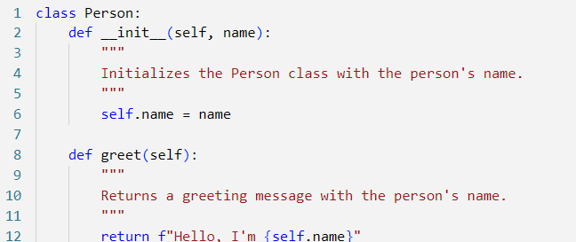

Task 2: Define the Base Class Employee
The Employee class contains a constructor __init__ that initializes the employee_id attribute.
The get_employee_id() method returns the employee's ID.
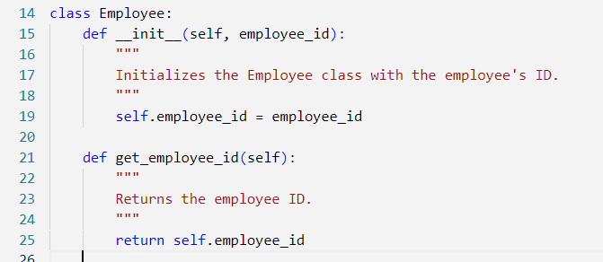

Task 3: Define the Derived Class Manager Using Multiple Inheritance
The Manager class inherits from both Person and Employee.
The __init__ constructor for Manager calls the constructors of both parent classes, Person and Employee, using their respective __init__ methods to initialize name and employee_id.
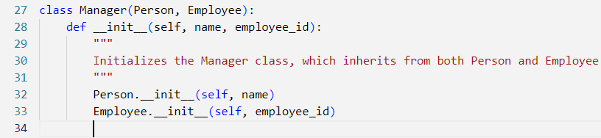

Task 4: Instantiate Objects from the Derived Class Manager

An object manager is created from the derived class Manager with the name "Ramar Bose" and employee ID "E12345."
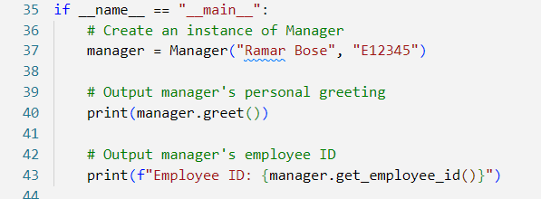

Output:
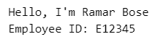

This program demonstrates multiple inheritance in Python by combining the functionality of two base classes (Person and Employee) into a derived class (Manager). The derived class can access and utilize methods from both parent classes, showcasing how multiple inheritance can be used to model complex relationships in Python

